January 2018

Esteemed Colleague in Surgery:

The College’s Division of Education and International Relations Committee are pleased to announce three international scholarships focused on surgical education. These awards, in the amount of $10,000 each, provide young faculty members from countries other than the United States and Canada with the opportunity to participate in a variety of educational opportunities for faculty development and enhancement that will result in acquisition of new knowledge and skills in surgical education and training.

The three scholars will participate in the Annual ACS Clinical Congress, including the course Surgical Education: Principals and Practice Course, as well as other plenary sessions and courses that address surgical education and training across the continuum of professional development. Following the Clinical Congress, the scholars will visit appropriate Level I ACS-accredited Education Institutes or similarly recognized and established centers with a plan of study and interaction tailored to their particular education-based focus.

Scholarship requirements and the online application form may be accessed from: https://www.facs.org/member-services/scholarships/international/issurged. Please note the new application deadline of 1 March 2018.

I seek your cooperation in publicizing the availability of the International Surgical Education Scholarships. The International Relations Committee of the College has requested that the requirements for the International ACS International Surgical Education Scholarships be widely distributed and we appreciate your kind cooperation.

Please note that scholarship applications and additional materials must be submitted in English.

Please direct questions to Ms. Kate Early, International Liaison, at kearly@facs.org.

Again, the deadline for receipt of all application materials for the International Surgical Education Scholarships is now 1 March 2018.

With many thanks for your kind assistance,
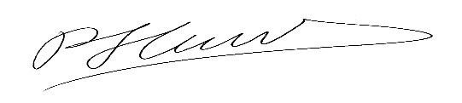
Patricia L. Turner, MD, FACS
Director, Division of Member Services

